Kl humne ye baat pade the ke jab bhaut bade samrajya ka patan hota hai to bahut chote chote rajyon ke utpatte hote hai
Bharat ke Madhya aur uttar Paschim wale chetro me vedeshe arthat Greek arthat yavano ke utpattee hote hai wahe bharat ke puriv aru dakshine chetro me swadeshi rajyon ke utpatee hote hai jo mukhya ruoop se brahman dharma ya vedic dharm ko mante the
To humen dekha ke india ke central aur north west regin me Greek rulers ate hai wahe india ke east aur south province me indeginous aur brahmin rulers dekhne ko mitle hai

Sathvahanas
Sathvahanas ke bare me intresting batt ye hai ke ye bharat per lagbhag 400 varsho tk shashan krte rahe ancient history me kise bhe dynasty ne itna lamba rule nahi kya hai bahut bada inka tim periid hai questin bhe puchete hai ke praching bharat me sabse lambe samya tk shashan karne wala rajvasnhs kaurn tha
To answer satvhand kae books me 300 aur kaie me 400 mention hai
Sathvahan ko Andhra satvahan ke naam se bhe jana jata hai aisa isley inke bare me do alag alag theory chalte hai ek theory hai ki inka origin andhrapradesh ke amravate wale regin me hua hai
Dusre inke origin ke theory hai ke maharastra me jo aurnagabad wla chetar hai wahah pratesthan naam ke Rajdhani to wahah se inke utpate hu hai origin hua hai yahe karan hai inhe andra sathvan ke naam se jana gayay hai
Mastsay puran me hume Andhra satvahan ke bare me bahut lambi chaude jankari milte hai

Sathvahan , Andhra bratya andhrajateya ye sabhe inke naam hai
Ye itheass me ku intan prasheesdh hua inme apko ek alag pratha dekhne ko milege

Isme kuch naam gautmi putra sathkane ke baad ke rajao me chke karo
Andhra sathavano ke rajao ne ek naee pratha shuru ke wo apne naam ke age apne mata ka naam lagate hai to iska matlab ye nahi hai ke smaaj matrastapmk tha samaja pitrastatmak he tha ye apen mata ke prate ek samman tha isse ye pata chalta hia ke women kae respect bahut Jayda rahe hoge but samaj patriarchal he tha kuki kabhe bhe kise mahela sahashek aka naam inke wansh me nahi tha only males rulen no women rune in theis dynasty
To agar matrastatbmak hot tha women bhe rulers hote hai aha wubt women ke respect the
To iss wajah se satvahan praseedh hai

Post Mauryan time per do famous hue hai ek sathvahan and dusra Kushan vansh

Satvhana ka first ruler tha simuk satkarna first great the
Haal ka shashan prashaans se Jayda sahetya literature k lyie charch me tha administration se kjyada literature me tha bahtu sare great liteatur work ist time per hue the

Yagyashree satkarni antim last great ruler tha jaise Mauryan me Ashoka last great ruler tha

Last ruler of sathvaans is pulumavi fourth
More than 30 rulers rulednd in this dynasty because they ruler over the period of 300 year
Hume sir famous char pach ke bare me he padna hai

Ye inek extreme extinision ke darshata hai ke ek samay pe inhone itne bade Chetra per shansan kyia tha
Gujrat me bhadoch naam ka ek port tha jo inka ek bahut mahdtvapuran prot tha see on map

Pratesthan inke capital the aur amravate bhe inke captioal rahe hai see on map

Pratesthan jjo ke mahrastra me Aurangabad ke paas wala ilaka hai
Haal me Aurangabad ka naam badalkar kya rakh dyia gaya hai

Sathvaahano ke pareele bhaut sare rjaja ya dynasty beech me shaashn kar rahe the
Western shatraps, Kushan empire shakio ke jo shaka Ujjain wale Chetra me the usko pashcami chatrap ya western chatrpa bhe bolte hai
Ancient Indian history me it is consider the longest ruling period by any dynasty

Simuk ko sindhuk aya siprak bhe bolte hai
Kanv vansh ke rajaj susharma ke htaya karke inhone sathvahan dynasty ke isthpana ke the

Kanv se pahle bhe yae alag alag isthanyia shashko ke ropp me kaam kar rahe the reginal rulers ke roop me kaam kare rahe the

Mukhya roop ise inhone andhrapradesh , telangak , andhrapradesh per shahsn kyia thia jisme Wartman madhyapradeh ka hissab bhe kuch samhil tha
Madhyapradesh ka Dakshin Paschim bhag ka jo Chetra tha us per bhe shahsn kyi atha aur Karnataka ka bhe kuch ilaka a
Teen jagha meian shashan kyia tha

1
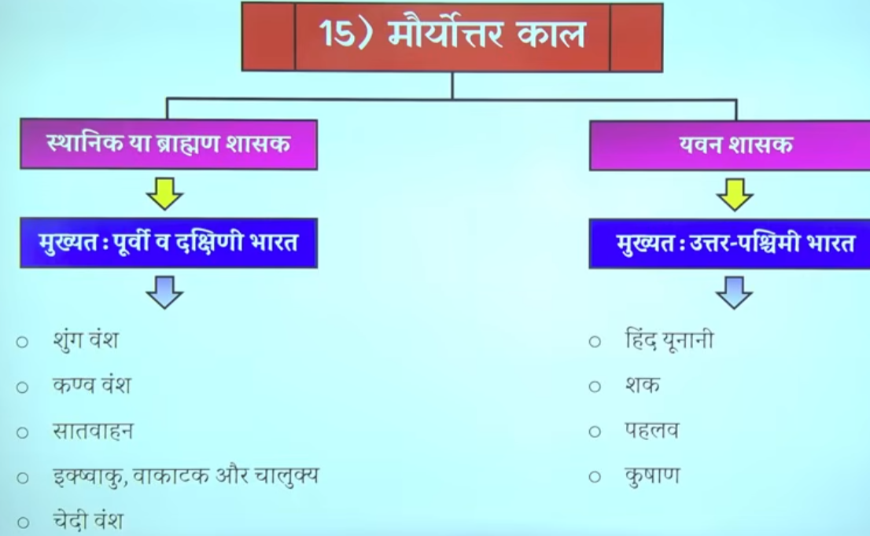

2 Satvahan Dynasty 1nd BCE - early 3rd CE

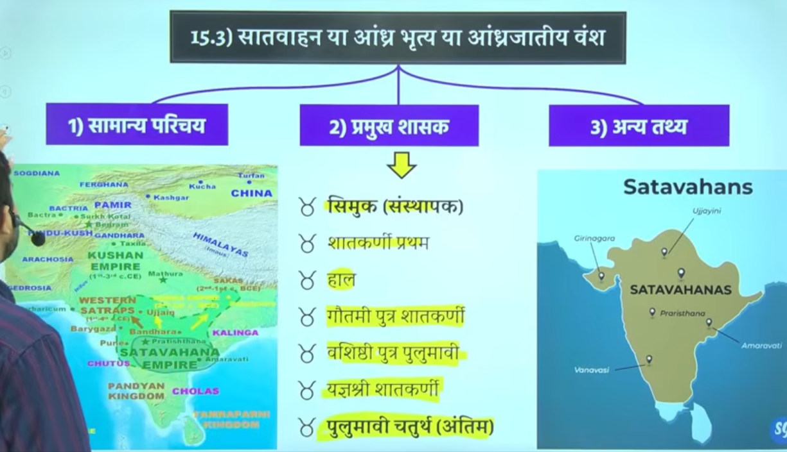

- late 1nd century BCE to the early 3rd century CE
- Area of Rule: Primarily covered the Deccan region, including modern-day Maharashtra, Telangana, and Andhra Pradesh. At its peak under Gautamiputra Satakarni, it extended to parts of Karnataka, Gujarat, Madhya Pradesh, and Saurashtra.
- Capitals: The capitals shifted, with primary ones being Pratishthana (modern Paithan, Maharashtra) and Amaravati (Dharanikota, Andhra Pradesh).
- Founded by Simuka, the dynasty lasted approximately 450 years, with peak power under Gautamiputra Satakarni (c. 106–130 CE) before declining around 224 CE

Caption: Satavahana Dynasty (1st Century BCE – 3rd Century CE)
The Satavahanas (also known as Andhras) served as a vital cultural and political bridge between North and South India, establishing a dominant empire in the Deccan Plateau upon the decline of the Mauryas. Their reign was marked by flourishing Indo-Roman trade, the extensive construction of Buddhist monuments (like Amaravati and Karle), and a decentralized administration that promoted economic prosperity, with their power reaching its zenith under Gautamiputra Satakarni.

The Satavahana dynasty, also known as the Andhras, ruled the Deccan region roughly from the late 1nd century BCE to the early 3rd century CE. Founded by Simuka, the dynasty lasted approximately 450 years, with peak power under Gautamiputra Satakarni (c. 106–130 CE) before declining around 224 CE.
Key Timeframe Details:
- Establishment: Late 2nd century BCE to 1st century BCE (Simuka is often dated around 60 BC, though others argue earlier).
- Reign Duration: The Matsya Purana suggests 460 years, though many modern scholars align with the 1st Century BCE to early 3rd Century CE range
.
- Decline: Early 3rd century CE (around 224 CE).
Important Rulers and Periods:
- Simuka: Founder.
- Satakarni I: c. 70–60 BCE.
- Gautamiputra Satakarni: c. 106–130 CE.
- Vashishtiputra Pulumavi: c. 110–138 CE.
- Yajna Sri Satakarni: c. 165–194 CE.
The Satavahanas acted as a bridge between the Mauryas and the Gupta Empire, controlling the Deccan and parts of Central India after overthrowing the Kanva dynasty.

3 Introduction

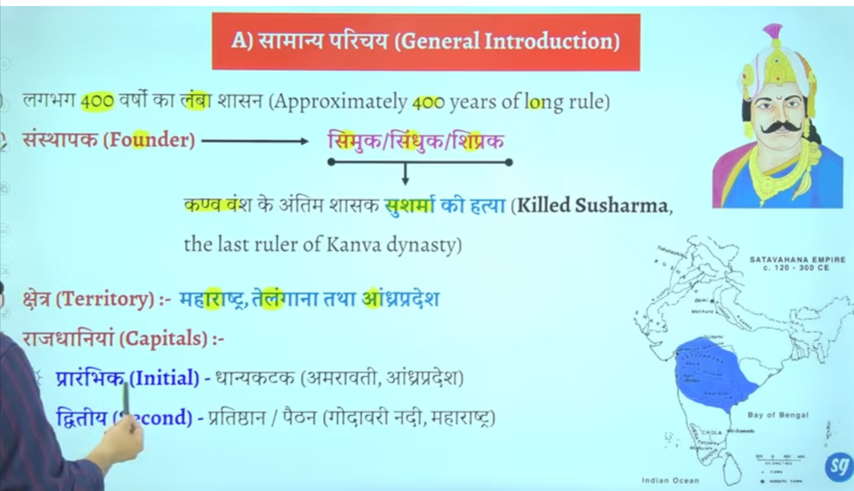
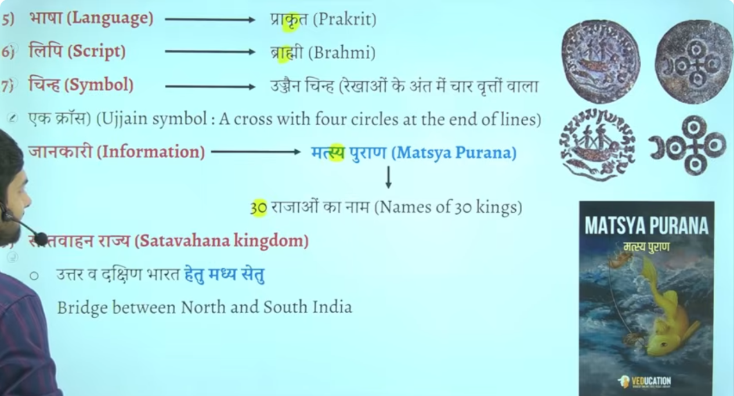

Second capital he inke main capital the prateeshan jo ken ashik wale region ke paas ate hai

Inke aupacharik bhasa official lagnauge jo the wo prakrat the aur lipi brahmi the
Isko hum vedic dharma ka punarutthan ka kaal bhe bolte hai ye pura ka pura period viedic dharma ke reconstruction ka phase hai
But inke official lagnague Sanskrit nahi the balik prakrat the sanskrat ka sabse adhik vikas hoga gutpa kaal me saknkakr ka exteme development hoga gupta period me yaha abhe bhe prakrat bharsa aur brahmil lipi ka use ho rahah tha

Sathvahan ke jankari hume Matsya pruna se milte hai
Mastsya purna me 30 kijng ka ullekh kyia gya hia
Question Matsya puran ka sambhand prachein kaal ke ksi mukhya roop se kis vansh se rahah hai to answer satvhana se rahah hai

Sathvahn ke 30 rajao ke jankir mastya pruan se mitle hai
Question mauryaon ke janskari hume kis puran se milte hai

Sathvan ne uttar aur daskshnin bharat ke beech me setu ki tarha kaam kyia they work as a bridge between north nd south india

Inke jo chinaha rahah hai usko Ujjain symbol boteh the
Ye inka official symbo hai isko lekar ke bahtu doutbh hai bahut sare book hai jo isko rectify nahi karte hai
Jo isko sahe nahi mante

Upsc question tha ek buddha stoupa hume dhanyakata se mila hai wo dhanyakata k kahah per hai
This question is related from here
Ans:Andharparesh
Because Amravati buddhist centre ke roop me bhe develp hoga is time period me Amravati dhanykatak wala jo Chetra hai

4👉 Simuka

📌 Key Points:
- 🕰️ Time: around 1st century BCE
- Satavahana Dynasty was founded by: Simuka
- 📍 Region: Deccan (Maharashtra–Andhra region)
- 🏛️ He established the first strong Satavahana rule after Mauryan decline

🧠 One-line:
👉 Simuka was the founder of the Satavahana dynasty.
The Satavahana dynasty (also known as the Andhra dynasty) defeated the Kanva dynasty. According to the Puranas, the founder of the Satavahana dynasty, Simuka (or sometimes referred to as Balipuccha or Sisuka in some records), killed the last Kanva king, Susarman, around 30 BCE-28 BCE, bringing the Kanva rule to an end.
Simuka is the founder of the ancient Indian Satavahana dynasty, establishing the kingdom in the Deccan region around the 1st century BCE (or potentially earlier, according to some theories). He is recognized as the first king in the Naneghat inscription and is credited with overthrowing the Kanva dynasty to establish Satavahana rule.
Key Details About Simuka and the Dynasty
- Alternative Names: In the Puranas, he is sometimes referred to as Sindhuka, Sipraka, or Chhismaka.
- Reign: He is believed to have ruled for approximately 23 years, with many scholars placing his reign starting around 30 BCE
.
- Capital: The early Satavahanas were based in the Deccan, with their capital initially at Pratishthana (modern-day Paithan) in Maharashtra.
- Succession: He was followed by his brother Krishna (Kanha), who extended the kingdom to the west.
- Coins: Coins bearing the name "Rano Siri Chimuka Satavahanasa" found at Kotilingala in Telangana are believed to be his, suggesting the region as the initial center of their power.
- Religion: According to some traditional narratives, he was initially a follower of Jainism but became a tyrant in his later years, leading to his downfall.
Simuka laid the foundation for a dynasty that would dominate the Deccan region for roughly 450 years and serve as a crucial successor to the Mauryan

Satavahana Dynasty did not have a single fixed capital because it was a regional empire with shifting centers of power.
Its main capitals were Pratishthana (modern Paithan) and sometimes Amaravati.
regional mepire means
🏛️📍 What does “Regional Empire” mean?
👉 A regional empire is a kingdom or empire that rules only a specific part (region) of a country, not the whole country.

🧠 Simple meaning:
👉 Regional empire = छोटा/सीमित क्षेत्र पर शासन करने वाला साम्राज्य

📌 Example:
Satavahana Dynasty
- It ruled mainly the Deccan region (South India)
- It did NOT rule all of India like the Mauryas did

⚖️ Easy comparison:
- 🟠 Maurya Empire = All India empire (big empire)
- 🟢 Satavahana Empire = Regional empire (only Deccan)

🧠 One-line:
👉 A regional empire is a kingdom that controls only one part of a country, not the entire country.

5

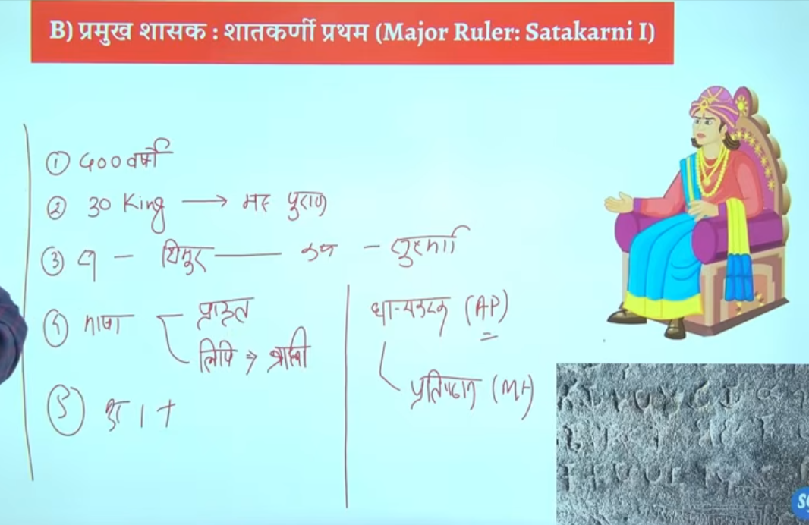

Is dynasty ka first prominent ruler ya mahan shahsak manaj jata hia
Wo hai satkarni Pratham
Saktakrini ke bare me jo hume jfankari milte hai wo inke wife nagneka ke nanaghat abhelekh insprition se milte hai jo mahrastra ke pune jile ke junnar me is the hai

Pune me ke jagah hai junnar junnar me he nanaghat abheelekh milta hai jise nayanika abhelkeh bhe kahah jata hai ya isee ko nagneeka abheelkhe bhe kahah jata hai
Ek he naam hai chae app nanaghat abheelkhe bolo ya nayanika abhelkeh bolo nagneeka abhelieha bolo

In sathvhan dynasty there are two inscription that are very very important
First is nanaghat inscription
Second is nasik inscription

Nanaghat inscritpon ko satkarni first ke wife nagneka ne lihwaya banwaya tha the nanagahat inscription is was inscribed by the wife of satkarne fiest nagnaeeka also called nayaneka
Wheras the nasik inscription inscribed by the mother of gautmi satkarni balshri gautmi or Gautami balshri

Nanaghat inscription isley important hai kuki ye bharat me bhumi anudan ka fiest sakshya hai first evidence of land grants in india to brahmins

Isse pahel kabe bhe logo ko bhumi dan nahi de jate the brahmano ko ya fir dusre logo ko kise ko bhe nahi
Genearly kya hota tha ki vihar banaw dyia ya mandi banwa dyia etc
Ab proer tareeke se land donate kyia jayega brahmano ko land grant de jayege buddishi ko land grant de jayege jains monks ko bhe land grant de jayege

To land grant ka first evidence is sathvahans se milta hai kb kbhe 1010 5050 village daan me de dyia jata tha vidhawano ko scolors ko ya brahmin s ko ya monks ko ya saints ko santo ko
Yahe se bharat me feudiliasm ke Shurat hue samantvaad ke Shurat hue the jisse age chalkar ke gutpas kae patan ka karna baen the jo bahut jyada effect kyiat tha guptas ko aur uske baad ke dynasty ya rajon ko
Man lo humen kese vyakti ko 100 gaon de dyia ab use kahah jata tha ki ab yaaha per sab kuch tumko sambhalna hai prashans bhe tum samhano halaki basic rule s rjaa ke he chalte the
Lenkin generalyy tum yaha ke sarvesarva ho tax ayega to tum collect kar lenga thoada bahut hoga to state ko de dena kuch to brahmdeya jaise jameen milte the brahmadeya aise jammen hote the jis per kise bhe prakar k koi bhe tax nahi lyia jata tha
Jisse samanto ne dhere chote chote rajya bana lyia aur jb state me kamjor shashak aye to inhe samnto ne un rajao ko alag kareke king maker ke bhumki banan shuru kar dyia tha
Yahe se bharat me samantvad ke Shurat hote the
Samantvad bhatu simple se philosophy hai ek vyakti hai jiske paas jameen ka bahtu bad tukda hai us jameen ka wahe malik hai us per use ka shashan chalta hai uar jo wahah se rajasva mil raha hai wo use se apna jeevan yapan karta hai
To prashna puchat hai ki brahmano ko bhumi anudhan ka pahla sakshay kaha se milta hai to answer is nanaghat abheliekhs se
6

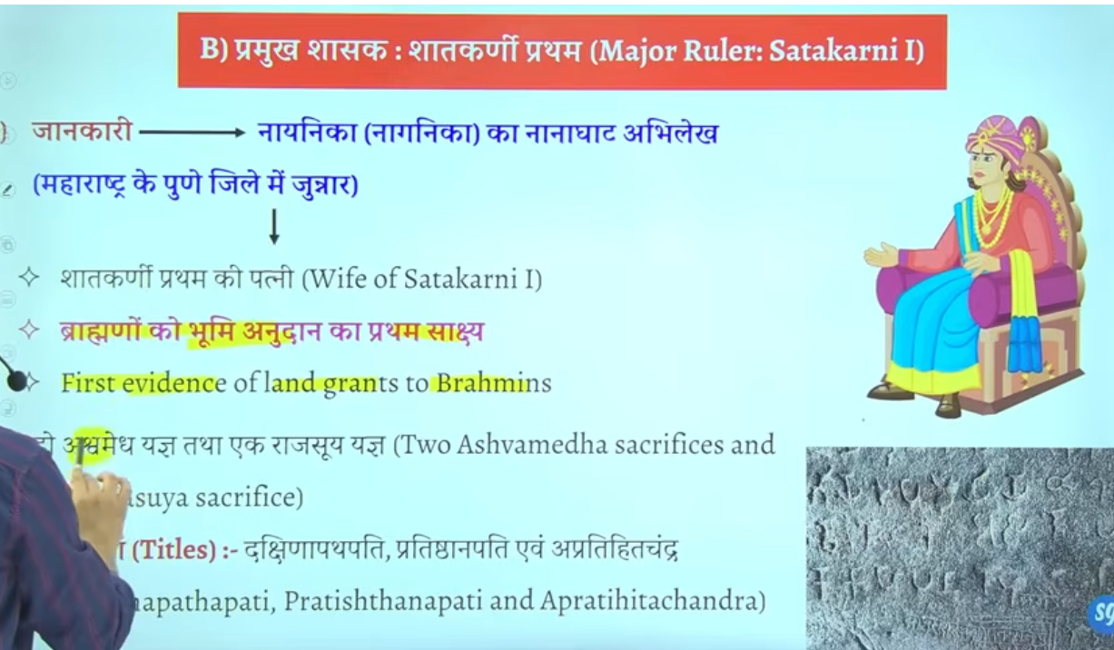]
Yaha e exam me do question bante hai
Oldest evidence of land grant in Indian is nanaghat aur sathkarni time period
Kisne banaya – to answer is pune me satkarni first ke wife nagneeka ne banywa tha ye pun eke junnar me is the hai

C HAAL
Haal ke time per apko adminstrativ wok jyada nahi milega litreatrue ya sahetya ka bhaut bada premi tha kaha jata hai ke Dakshin bharat me sahetya ke sabse bade premyiaon aur sanrakshako me haal ka naam shamil hai bahtu sare vidwaaano ko isne sankrakshan dyai tha
Isek time per bhaut saren grantho ke rachna hue the
Ye khud bhe ek bahut bada scholor tha haal ne ek famous book likhe hai gatha saptsati
Question gatha saptaste book kiske dwara likhe gae to answer satvahan raja haal ne ye book likhe the
Ye book prakrat bhasha me hai jisme prem aur shivaaa ke bare me charch ke gaee hai
Prakrat sahtvahano ke aupchariek official bhasha hai

Iske darbar me bahtu sare scholor rahet the

Prachin bharat ke sanskrti ke mahan vidwano me acharya padini ka naam ata hai patnajali aur sarvarman ka naam bhe ata hai
Sarvarman ne katantra book likhe sanskrti graamar hai one of the greatest work on Sanskrit grammar
Haal ke jo rani hai malyavati hai wo bhe Sanskrit ke bahtu bade scholor the

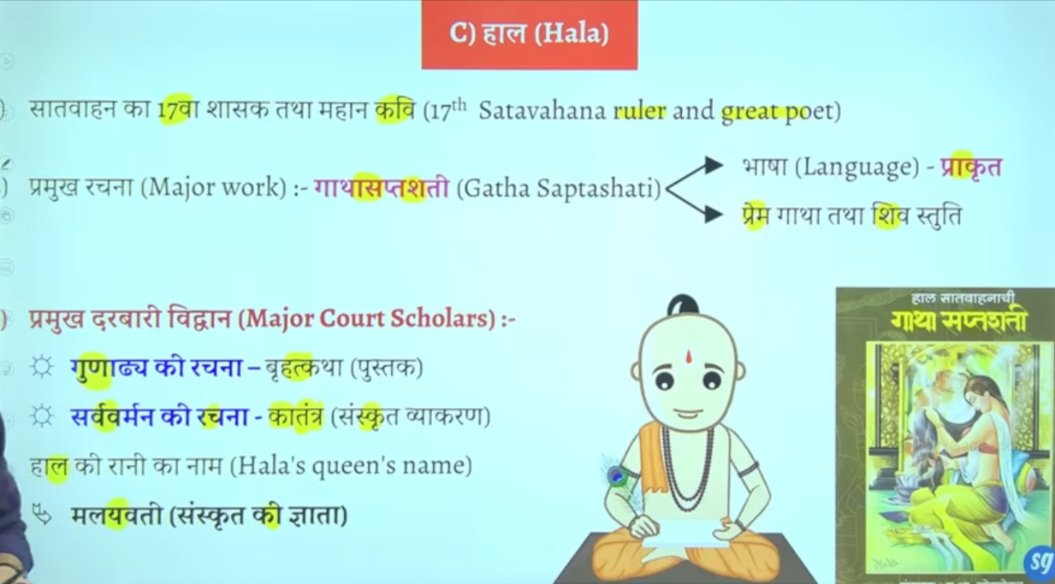
Book me prayer of shivaaa hai gatha saptshati

Greatest ruler of sathvaha is Gautami putra satkarni
He is the main ruler
Yahe seek prarmapra ke shruat hoge ke satvhan shashak apne naam ke pahel apne mata ka naam lagana shur karenge gautmi balshri inke mata ka naam tha
Ek samaya aisa ayega ke inke seemaye tamilanidu and kerla tk touch honge
Inke time per extreme expansion hoga
Inke bare me jankari hume nasik inscritpon se milte hai

Jisse inke mata gatumi balshri ne likwaya tha nasik inscritpon isse hume bahtu sare jankari milte hai regarding gautmai putra satkarni
Inhone bahtu sare title upadyia le the

Jisprakr shung ne durbar se vedic dharma ka uttahn kyai uske punaristhapan ke waise he gautpmi putra satkarni ne bhe vedic dharma ke uttan ke lyie bahut sare kaam kyie the vedic relgion ke rejunvendation ke lyie bahtu sare kaam kyie the

Kis rjaj ko varna vyavsth ka rakshak kaha gay to gautmi puta satkarni kise vedo ka ashryadata kaha gya too same answer
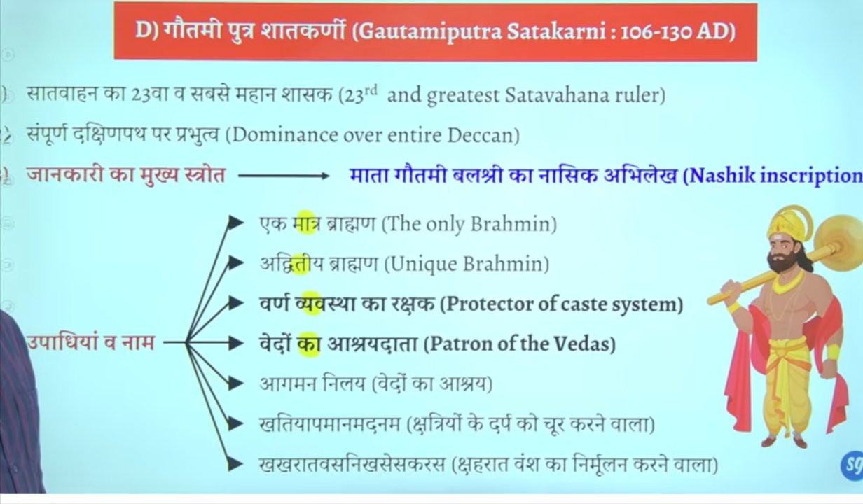

Panavlene ke caves kaaha per hai to anseer hai ye nasik mahrastra me hai
Nasik prashti ko he mahrasta me nasik gufa cave bhe bolte hai

Ye panavlene ke cave hai ineme he apko nasik inscritpon milega

West me sako ke ek shakha branch the wester shatrap rule karte the inke he ek aur shaka branch the jisko shahraat kaha jata tha iska ke rajah tha nahpaan jisko harya tha gautmi putra satkarni ne

Aisa nahi hei ke sirf brahmano ko daan dyia gaya balik buddha aur jain monk ko bhe daan dyia gaya tha land grants
Jaise narjak aur ajaakalkyia naam ke do village the jo budhha sangh council ko daan me dyia gaya tha
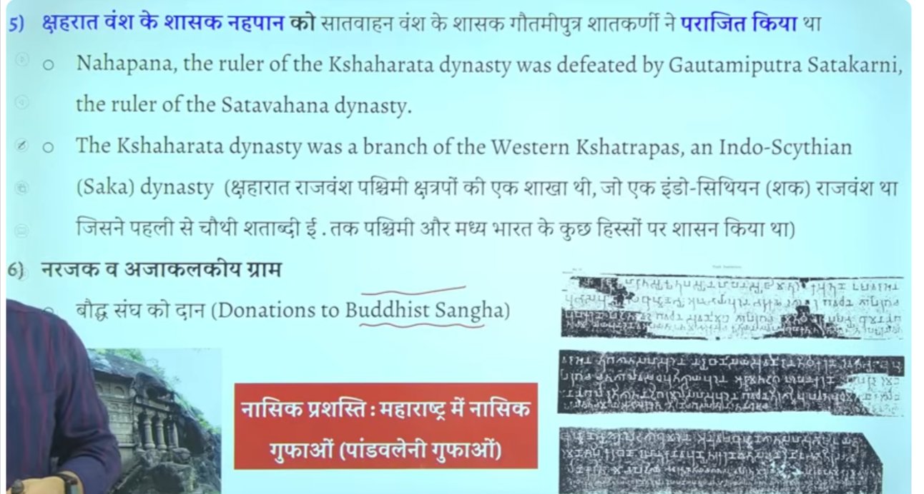

Nasik abheelke inscritpon hume pandavlenek cave nasik se pratpt hota hai jisme isko bahut sare title dyia gaye hai

Shako ke sharahat branch se nahpaan ata tha cythina ruler nahpana tha

Vashtiputra pulvamaiv
Ye bhe ke imprtonat aur mahan raja hue hai sathavna time ke

Sathvan vansh ke kaun se raja the jinhone dakshinapatheswar ke upade title lyia tha
To answer is vashisdha ptura pulvami
Ikse alaw title tha Andhra smarat and puloma

Inke jankari hume kanheri inscritpoin se milte ahi usme likha hai ke shak rjaja rudrdaman ne vashtid putra pulvami ko hara dyia tha
Shako ka mahan rja tha ruddraman jisne jungarh ka inscription bhe ankkeet karwaya tha
Firs isne pulavami ne rudradaman ke beti se shadi kar le aur dono ke beech sandhi hog ae the

Iske sikko per do patvaar wale jaha the
Jisse ye pata chatla hai ke kahe na kahe inhone navy bhe bana le the aur ship ka proyog karne lage the

Kuki satvahan roman se bahut sara trade vypar karte the kuki bahtu bade matra me roman coins india se mile hai
Q us raja ka naam bato jisek sikko per do patvar wale jahah ka chinha mila hai to answer is vashdi putr apulvami
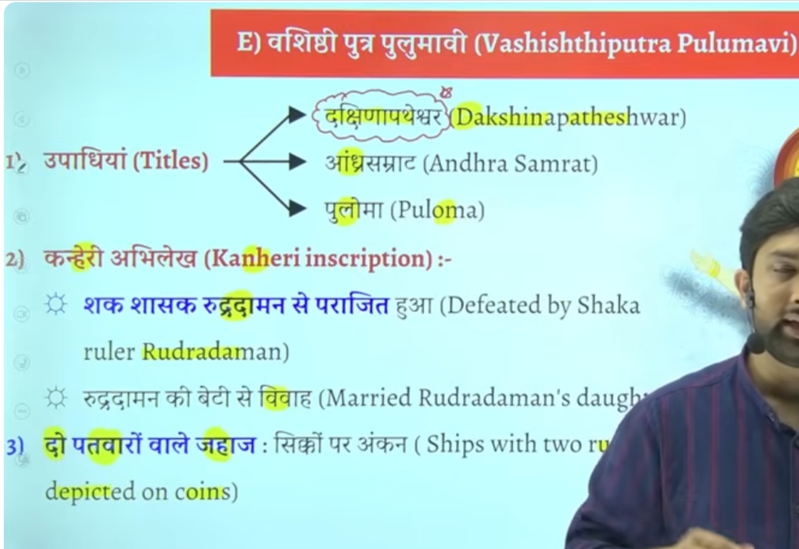

Pulomavi IV
The Satavahana dynasty ended around 225 CE following the death of its last main-line king, Pulomavi IV. The empire fragmented into five smaller kingdoms, with the Ikshvakus taking over in the Andhra region, and others like the Abhiras, Chutus, and Pallavas rising in other territories.
Testbook +2
Key Details on the Fall:
- Last Ruler: Pulomavi IV is generally considered the final ruler.
- Cause: After Yajna Sri Satakarni (the last "important" ruler), a series of weak rulers failed to hold the vast empire together.
- Successor States:
  - Andhra region: Ikshvakus.
  - Maharashtra region: Abhiras.
  - Mysore region: Kadambas.
  - Other areas: Chutus, Vakatakas, and Pallavas.
- Conflict: The dynasty was weakened by long-standing conflicts with the Western Kshatrapas.

Facts

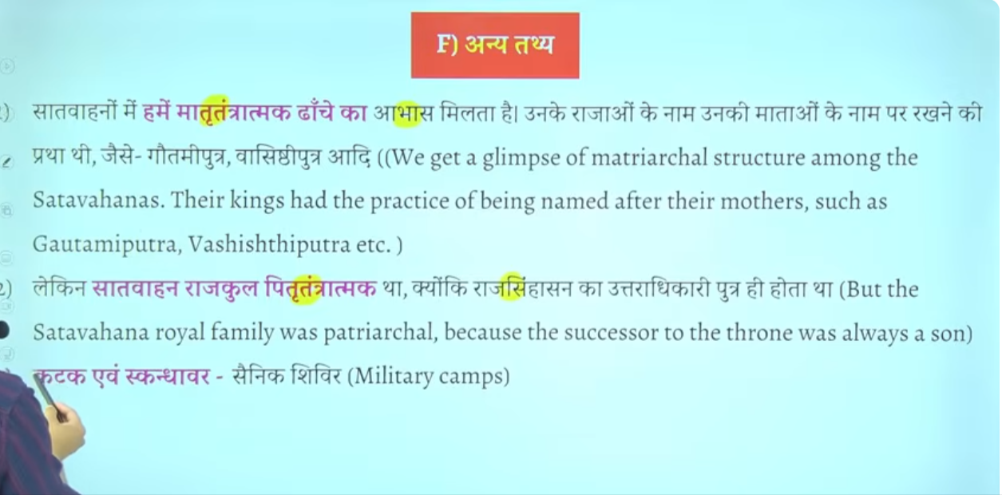

Katak aur iskandhawar ye military camps ke lyie use wone wala word tha ye saineko ke shiver ko kahah jata tha
Gaulmik = ekadhikari hota tha jo gram prashashan ka pramukh hota tha
Baki inka prashans Maurya kaal ke tarha he tha bas ek do word he importna thai
Ye ruler administration ka head hota tha ikse jimedare hote the ek ye ek sena ke tukade ko maintain karta tha military ke ek wing ko bhe maintain kart atha
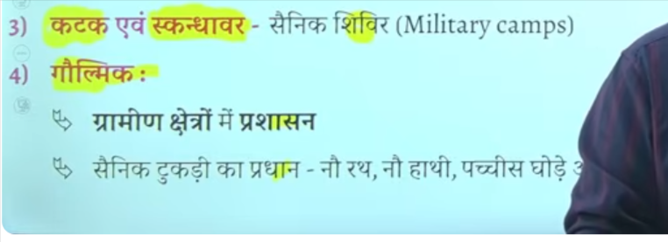

Bhut bade matra me roman sikke mile hai india se jisse ye pata chalta hai ke inke time per romans ke sath vyapar trade bahtu acha tha

Potin me seesa taba copper kansa in sab ko mila dyia jata tha

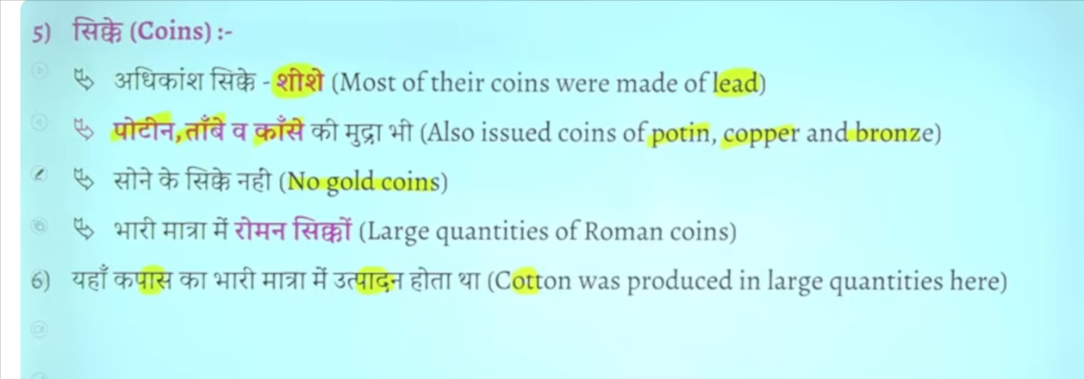

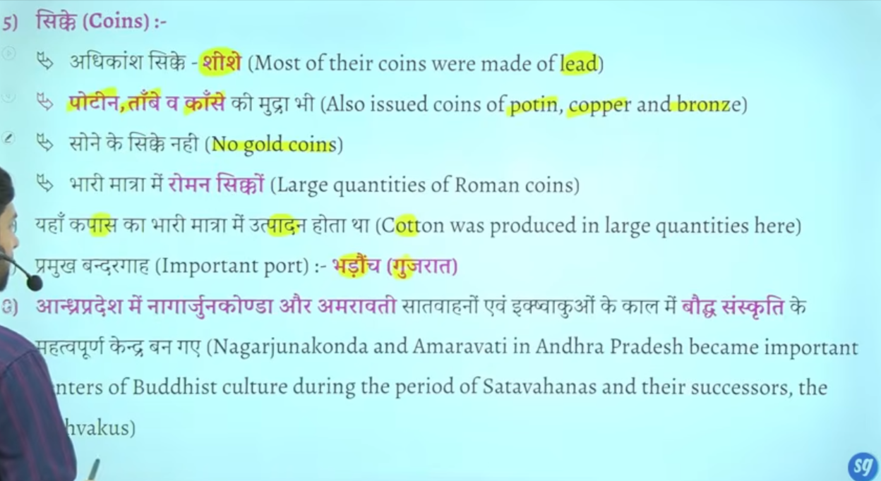

Gautmai putra satkarini vedic dharma ke sath anya dhrmo ka bhe samamn kartha tha baki dharmo ke lyei bhe karya kyai aur daan dyai aisa nahi hai ke sirf brahamano ke lyie daan hau baki dharmak ka bhe sanrkashan kyai tha
Andraprades me nagarjunkonda , dhankatak Amravati buddha sansktri ke important centraer the
Daskhin bharam me important budhsit center ban gae the
Danykatka Amravati me to stup aur chaitya bhe dekhne ko milte hai
Jaise pune maharastra me karle beds eke cave bane gae the
Jaha karle chaitya ka Nirman hua tha
Vihar wo jaahg jaha buddha monk rahte the
Chaitya wo jagha jaha per wo puja karte the

To karle chaitya aur bedse cave kaha ishte hai to anser is pune mahrasta me

Sath he satvahan shasko ne ajanta aur elaalor me bhe kuch gufao ka Nirman karwaya hai

Ajanta aur ellor ke gufaye aise hai jisme satvahan rastrkoot vaktaka bahut sare king ne kaam karwaya tha
Multiple rulers ka contribution rahah hai to sathvahana ka bhe yogdaan rhah hai jo mahrasta me pae jate hai

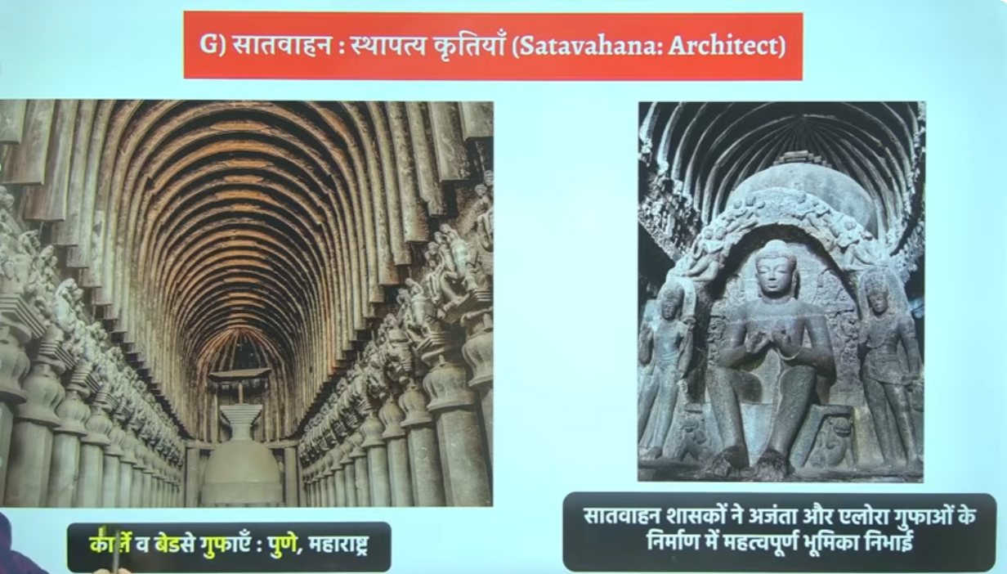

jb deccan me sathvahan dyasnty the tb south me aur norht me kuan se dyansty the and madhag me bhe kuns se dyanty the
🗺️📜 When Satavahanas ruled Deccan, who ruled North, South & Magadha?
Satavahana Dynasty (c. 1st century BCE – 3rd century CE) ruled mainly the Deccan region, while India was politically divided into many regional kingdoms.

🟢 🌄 1. Deccan (Central South)
- Satavahanas (main power)

🟡 🏛️ 2. North India (different periods, different powers)
During Satavahana period, North India was NOT unified. Major powers were:
- Indo-Greeks (earlier phase in northwest)
- Indo-Scythians (Sakas)
- Kushanas (very important, c. 1st–3rd century CE)
- Small local kingdoms in Gangetic plains
👉 Most powerful later northern empire:
Kushan Empire

🔵 🌄 3. Magadha (Bihar region)
Magadha was NOT a strong empire at this time. It was weak and divided.
- Kanva Dynasty (early phase)
- Later regional small powers
- Gradually came under influence of Kushanas in some areas
Kanva Dynasty

🟠 🌿 4. South India (beyond Deccan)
South India also had independent regional kingdoms:
- Cheras (Kerala region)
- Cholas (Tamil region)
- Pandyas (southern Tamil region)
Sangam Chola Dynasty
Chera Dynasty
Pandya Dynasty

🧠 📌 Easy summary:
👉 Satavahanas = Deccan power
👉 North India = Kushanas + Sakas + small kingdoms
👉 Magadha = Kanva (weak, declining)
👉 South India = Chera, Chola, Pandya kingdoms

🧠 One-line UPSC answer:
👉 During the Satavahana period, India was politically fragmented with Satavahanas ruling the Deccan, Kushanas dominating North India, Kanvas declining in Magadha, and Chera-Chola-Pandya kingdoms ruling South India.

If you want, I can make a single timeline chart (very easy for revision) 👍

ISVAKU

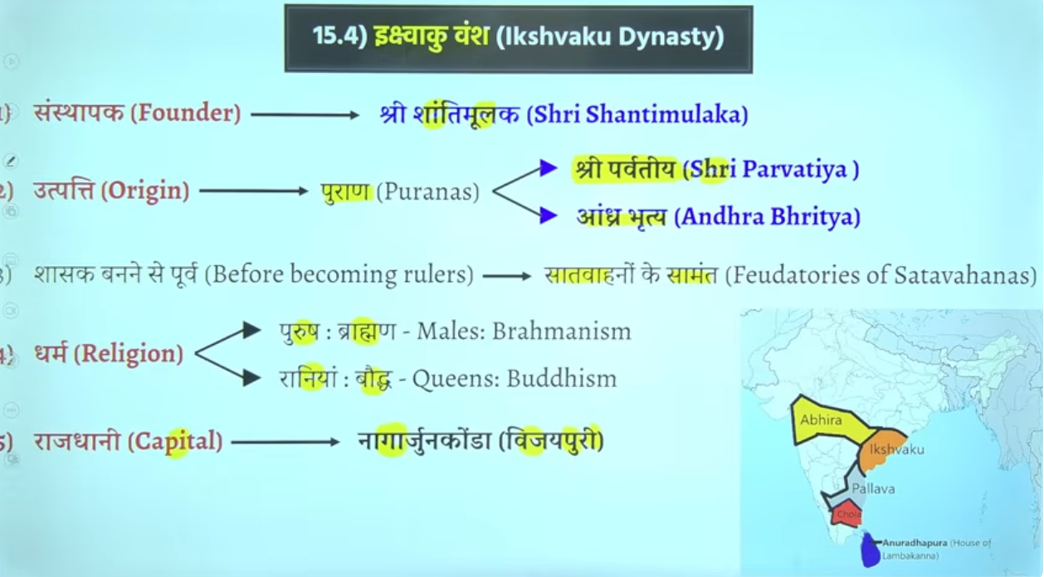

Iskvakou vansh bahtu sare hue hai bharat me ke pracheen kaal me ramayna kaal ke time per iskvaku vansh tha
Abhe hume jis dynasty ke baat kar rahe hai wo hume later ancient historyke period me dekhne ko milta hai

Andhrabratya naam satvhaano k lyie bhe use hota hai
Q shree parvateeya kise kaha gaya hia to answer isvakeu vansh ke rajao ko

Shaahak bane se pahle ye satvahna key aah samant the
Bhumi anudaan ke pratha hai wo samant vaad ko janm dege aur jo ultimately shaktishaale samant hai ya jo powerfule samant hai wo state ya rajya ke isthpana kar lenge wo state ko develop kar lege

Andharaprasdsh me isvaku ka shaashan raha hai
Capital nagarujunkonda ya vijayepure bhe bolte hia usko

Capital andrapradesh wale region me is the the

Vakatak dynasty

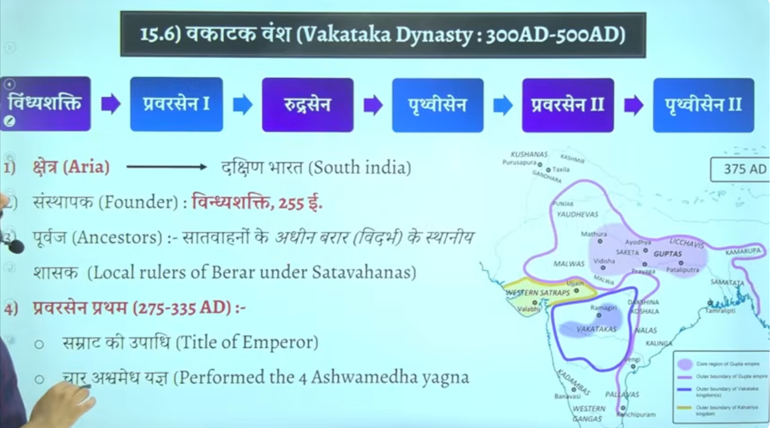

Vaktak vansh ne bhe lagbhag 200 saalo tk shashan kyat ha
Inke shashan kaal ke bare me intresting baat ye hai ke ye gupta kaleen shashako ke samkaleen he shashan karenge
Gutpat empire north me
Uske neeche vaktaka
And in dono ke center me west me western shatrapas (Shakas) honge

Changrautpa second ke bete ka naam tha prabhavate unke betae ka nam tha prabhavati inhone apne beti ka shakdi vakatak vansh ke rajaj rudrasena second se ke the
Inke shadi changraptua second ke bete prabhavit gupta se hue the

Gupta ne shadi k uke
Kuki vakatak ek abhaut acha jareya tha shako ko harane ka kuki agar dono side se attack kar dyia jaye to asane se hara sakte the kuki shaka in dono ke center west me the
To changratuap second ne aisa soch kar shadi ke the aur aisa hua bhe
Aur fir uske baad ek ghtna bhe hog ae ki shadi ke such ssaaal bdd rudrasena second ke death hog ae the
Unke do bete the but dono minor the alpvayask the to prabhavit gutpa ne shasan kyai tha to prabhavit gutpa ka shasank kaal ko swarn kaala maan gaya tha
Kuki gupto se vakatak ke sambandh bahtu ache rahe
Iske bad shako ke bhe khtm kar dyia gaya tha

To vaktak ka mahtavha ye hai ke ye gutpa ke samkaleen contemporty he shahsan karenge

Inke Chetra andrhapdes, Karnatak , mahrasta, telangal ka cetra tha suth me
Inke samkaleen bahut sare rjaa the jaise
Kadamba dynasty karnatka vale
Ganga vansh hai kerla ke ass paas
Pallav hai vengi hai kalinga hai nala hai
Aise bahtu sare chote chote dynasty the
Tampralipti bandargha pashcim Bengal me hai yellow se on map

Inke founder the = Vindhya shakti

Inke ancestor local ruler the satvhaahan ke adhen barar vidharm ke local ruler the starting me

Praveersena firsth ne ashvamedh ke upadi dharan ke the aur char ashvamedh yagya kye the

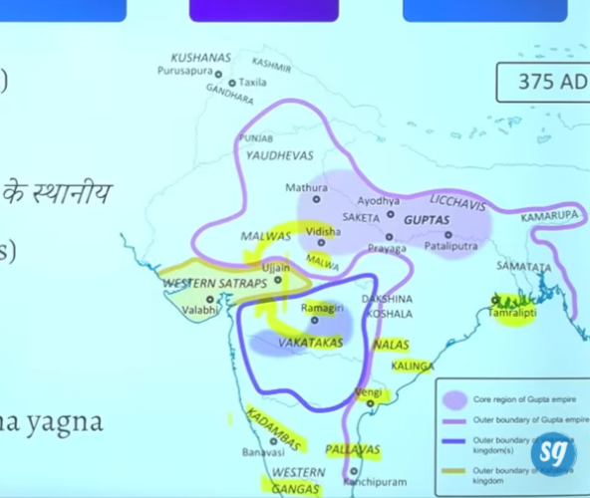

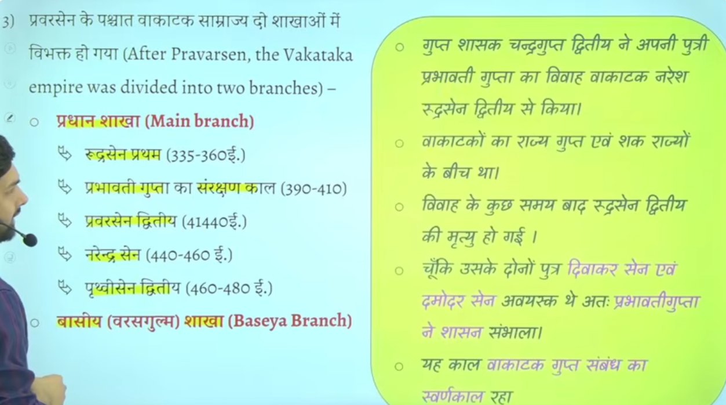
Praversen ke baad vakatak do alag alag shakaho me baat gayay tha ek Pradhan shaak dusre basyesa branch
Pradhan shaka me imporatna mukhya shashak hue the rudrasena first aur jo dyai hai

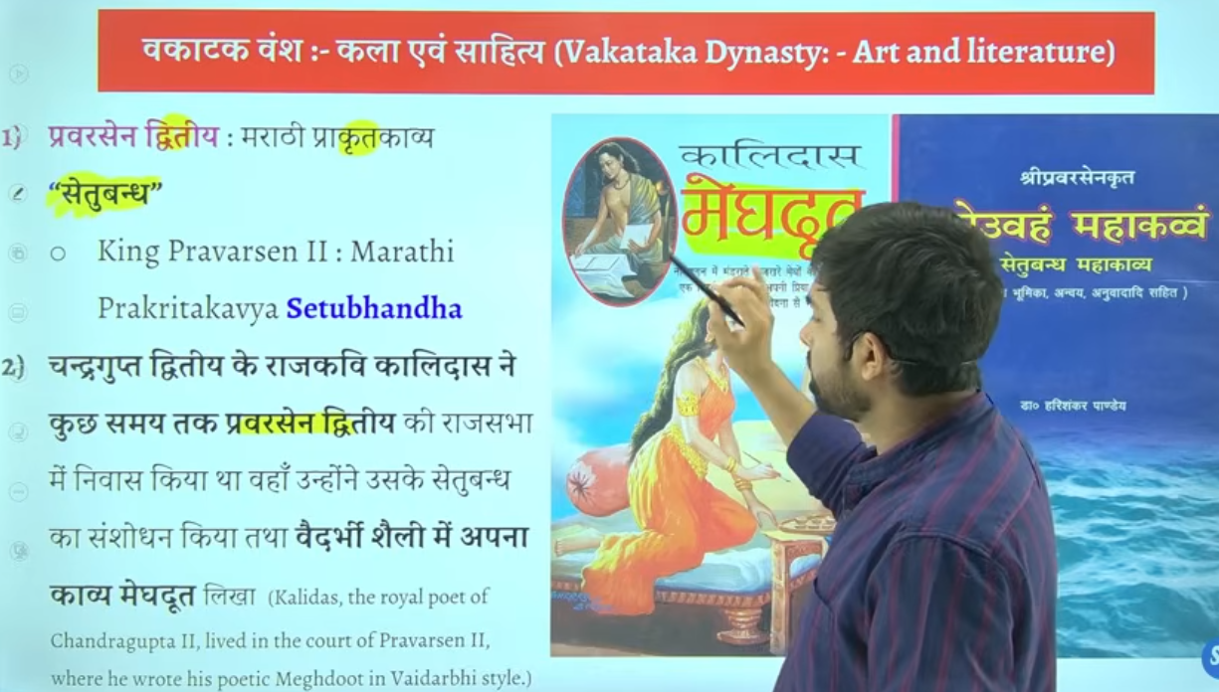

Praversena second ne ek maradi prakratkavya likha tha setubandh
Mahan marathi kavaya hia setubandh jiske rachna praversena second ne ke the jo ke vaktak raja tha
Means vaktak raja praversena second ne ke the

Praversena second jb setubandh ke rachna kar raeh the to unhe usme help chaye the
Chandragutpa second ke darbari kavi mahavakiavi kalidas vkatak k rajya me akar rahe the
Wahah per unhone na sirf setubandh me sansshodan kyia balik
Yahe per unhone apne ke mahan book likhe megadoot

But ikso kuch historian sahe nahi mante
Yaha se sawal setubandh se banta hai dusra saval banta hai prabhavati gupta se and ruderasena se

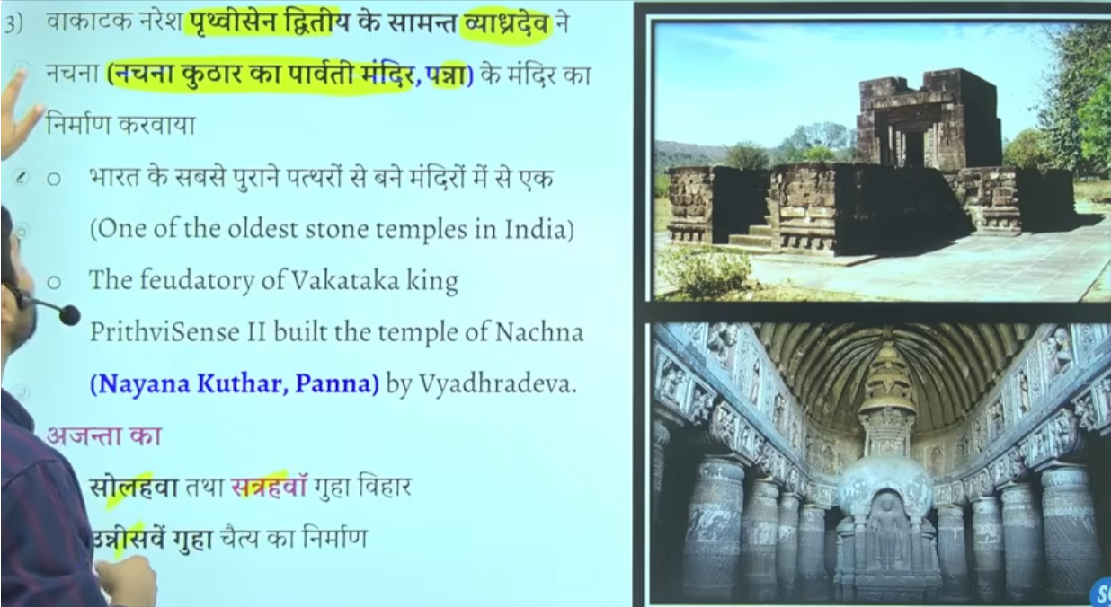

Nachna kudhar ka Parvati mandir panna me hai it is one of the oldest stone temple of india
Aur ajanta ki 16 17 and 19 ve cave me bhe inka yogdan rahah hai vaktaka ka

Praversena second ka shasahankal sahetya literature work k lyie important rahega
Praverssaena second ne khud ek kavya likha setuband jiske sansahodan mahavaki kalidas ne kyia tha

Vyagradeva jo ki prathvisena second ke samant the inhonr panna madhyapradehs me Nachna kudhar mandir ka Nirman kyia tha
4

❗ Important Clarification
👉 Satavahana Dynasty mainly Deccan (South India) mein the
NOT originally Magadha rulers

🏛️ Then Kanva ke baad Magadh ka kya hua?
- Kanva dynasty ke baad Magadh mein koi strong central dynasty nahi aayi
- Yeh period kehlaata hai 👉 Political Fragmentation

📍 Kya hua tha actually?
- North India (Magadh area) mein:
  - Chhote-chhote regional kingdoms aa gaye
  - Koi powerful empire nahi tha
- Meanwhile:
  - Satavahanas Deccan mein powerful ban rahe the
  - Unka direct rule Magadh par nahi tha, bas kabhi-kabhi influence ho sakta hai

⚠️ UPSC Trap
👉 “Kanva ke baad Satavahana Magadh mein aaye” — ❌ Wrong (strict sense mein)
👉 Satavahana = Deccan power, not Magadh successor

🧠 Correct Understanding
👉 Shunga → Kanva → (Magadh mein fragmentation, no major dynasty)

⚡ One-line
👉 Kanva ke baad Magadh mein political fragmentation hua, na ki kisi ek bade dynasty ka rule.

Agar chaho to main Magadh ki full dynasty timeline (Bimbisara se Gupta tak) short trick mein de deta hoon 👍
not undrstood
No problem—let’s make it very simple 👍

🧩 Step-by-step समझो:
1️⃣ Sequence पहले
👉 Shunga → Kanva → ?
तुम्हारा doubt यहीं है ❓

❗ Key Point (सबसे important)
👉 Kanva ke baad Magadh mein koi bada empire nahi aaya
✔️ कोई single dynasty rule नहीं कर रही थी
✔️ Area टूट गया छोटे-छोटे राज्यों में
👉 इसे कहते हैं: Political Fragmentation

🗺️ Satavahana कहाँ थे?
👉 Satavahana Dynasty
- South India (Deccan) में rule करते थे
- Magadh (North India) के ruler नहीं थे

🔍 Simple Example
सोचो एक बड़ा empire था (Kanva)
➡️ वो खत्म हुआ
➡️ अब पूरा area छोटे-छोटे kings में बंट गया
👉 कोई “next big dynasty” नहीं आई

🧠 Final Answer (Exam)
👉 Kanva ke baad Magadh mein political fragmentation hua
👉 NOT Satavahana rule

⚡ One-line Trick
👉 Shunga → Kanva → No major dynasty (Fragmentation)

अगर अभी भी doubt है, तो मैं timeline diagram बना के super easy तरीके से समझा दूंगा 👍
सातवाहन वंश मुख्य रूप से दक्षिण भारत (दक्कन क्षेत्र) के शासक थे, न कि मगध (उत्तर भारत) के। वे 200 से अधिक वर्षों तक महाराष्ट्र, आंध्र प्रदेश और कर्नाटक के क्षेत्रों में सक्रिय थे और उनकी राजधानी प्रतिष्ठान (पैठण) थी, जो महाराष्ट्र में गोदावरी नदी के तट पर स्थित थी।
Testbook +3
- शासक क्षेत्र: सातवाहन वंश ने मुख्य रूप से दक्कन क्षेत्र में शासन किया, जो वर्तमान महाराष्ट्र, आंध्र प्रदेश और कर्नाटक में फैला हुआ था।
- अवधि: उन्होंने लगभग 230 ईसा पूर्व से 220 ईस्वी तक शासन किया।
- राजधानी: उनकी राजधानी प्रतिष्ठान (वर्तमान पैठण) थी।
- उत्तराधिकारी: वे मौर्यों के बाद के प्रमुख दक्षिण भारतीय शासक थे, जबकि इसी दौरान मगध में कण्व वंश शासन कर रहा था।
- अन्य नाम: पुराणों में उन्हें "आंध्र" कहा गया है, जबकि अभिलेखों में उन्हें "सातवाहन" कहा गया है।
YouTube +4
हालांकि, सातवाहन राजाओं ने उत्तर की ओर अपने राज्य का विस्तार किया था, लेकिन वे मूल रूप से दक्कन-केंद्रित थे, न कि मगध के शासक

जब दक्कन में सातवाहन वंश (लगभग 1ली शताब्दी ईसा पूर्व - 3री शताब्दी ईस्वी) का शासन था, तब मगध (उत्तर भारत) में कण्व वंश के पतन के बाद छोटे-छोटे स्थानीय शासकों और विदेशी शक्तियों का प्रभाव था। कण्वों (73-30 ईसा पूर्व) के बाद, कुषाण, शकों (Western Kshatrapas), और शुंगों के बचे हुए अंश उत्तर भारत के विभिन्न हिस्सों पर राज कर रहे थे, न कि एक केंद्रित मगध साम्राज्य।
BYJU'S +1
मुख्य बिंदु:
- कण्वों का अंत: सातवाहन राजा सिमुक ने अंतिम कण्व राजा सुशर्मन को हराकर उनका अंत किया।
- मगध की स्थिति: उत्तर भारत में कोई एक केंद्रीय शक्ति नहीं थी। मगध सहित उत्तरी भारत के विभिन्न हिस्सों में कुषाण, शक, और स्थानीय शासक मौजूद थे।
- समकालीन शक्तियां: उत्तर में कुषाण और पश्चिमोत्तर में शक शासक सातवाहनों के समकालीन और प्रतिद्वंद्वी थे।
BYJU'S +3
संक्षेप में, कण्वों के पतन के बाद, उत्तर भारत में मुख्य रूप से कुषाणों और शकों का वर्चस्व रहा, न कि मगध में किसी एक बड़े देशी राजवंश का।
sathvahano ne deccan per shahsan kyia to fir unhone magadh me kanva ko ku hatya jb unhe whaha shahsna nay kya to fir
Good question — this is exactly the kind of UPSC “confusion area” (political geography vs power influence).

🏛️ First clarify the idea:
The Satavahanas did NOT directly rule Magadha permanently.
Their main base was the Deccan (Andhra–Maharashtra region).
So the question is:
👉 If Satavahanas ruled Deccan, why are they linked with Magadha (Kanva dynasty)?

⚔️ What actually happened?
1️⃣ End of Mauryas → Magadha weak
- Mauryan Empire falls (~185 BCE)
- Shunga dynasty rules Magadha
- Later Kanva dynasty replaces Shungas in Magadha (c. 73–28 BCE)

2️⃣ Satavahanas rise in Deccan
Satavahana Dynasty
- Started in Deccan region
- Founder: Simuka (early Satavahana ruler)
- They were NOT originally Magadha rulers

3️⃣ So where does “Magadha interference” come from?
During the late Shunga–Kanva period:
- Central authority in Magadha became very weak
- Satavahanas were expanding influence northwards
- But:
👉 They did NOT permanently conquer Magadha and rule it like Mauryas
Instead:
✔ They raided / influenced border regions
✔ They interacted with north Indian powers
✔ But Magadha remained under local dynasties (Shunga → Kanva → later others)

4️⃣ Kanva dynasty actually ended differently
Kanva Dynasty
- Kanvas ruled Magadha after Shungas
- They were not “removed by Satavahanas”
- Instead:
👉 They were overthrown by regional powers in eastern India (including emerging forces like Shungas remnants, and later others in north India)

📌 Important correction (very important for UPSC)
❌ Satavahanas did NOT “remove Kanvas from Magadha” as a direct conquest
✔ Magadha changed hands due to internal regional instability in North India
✔ Satavahanas mainly remained a Deccan imperial power

🧠 Final Simple Explanation
👉 After Mauryas, Magadha became weak and changed dynasties (Shunga → Kanva), while the Satavahanas rose independently in the Deccan. They did not permanently rule Magadha; instead, India became divided into multiple regional kingdoms with overlapping influence.

📌 One-line UPSC answer:
👉 The Satavahanas were primarily a Deccan power and did not directly rule Magadha; Kanvas ruled Magadha after Shungas, and the transition of power in Magadha was due to internal regional fragmentation, not Satavahana conquest.

If you want, I can draw a timeline chart (Maurya → Shunga → Kanva → Satavahana parallel map) to make it crystal clear 👍
kanva last king ko kisne harya
👑⚔️ Kanva Dynasty – Last King & Who Defeated Him
Kanva Dynasty ruled Magadha after the Shungas (c. 73–28 BCE).

👑 Last King of Kanvas
- Susarman (also written as Susarman / Susharman)

⚔️ Who defeated him?
👉 The Kanva dynasty was overthrown by the Satavahanas (Andhras) in traditional accounts.
- Satavahana Dynasty expanded from the Deccan
- They ended Kanva rule around 28 BCE

📌 UPSC Important Note (very important)
- Kanva dynasty was small and weak
- Their fall marks the end of Shunga–Kanva Magadha phase
- After them:
  - Magadha again became fragmented
  - New powers rose in different regions

🧠 One-line answer:
👉 The last Kanva king Susarman was defeated by the Satavahanas, ending the Kanva dynasty around 28 BCE.

If you want, I can also give:
✔ Shunga vs Kanva comparison
✔ Full timeline of Magadha dynasties
✔ MCQs for revision 👍
so if sathvand didi not rule on magadh to fur aise ku ke inhone kanvad dyansty ke last ruler ka mard kar sathvandhan dyansty isthaptik kyia
Good doubt — this is where UPSC history sources + “legend vs confirmed history” confusion happens.

🧠 First clear fact:
👉 The idea that Satavahanas killed the last Kanva king and directly established rule in Magadha is NOT strongly historically confirmed.

⚔️ Then why do some books say this?
Because of ancient texts + later traditions, especially Puranic accounts, which say:
- Kanva dynasty ended around c. 28 BCE
- It was overthrown by Andhra/Satavahana power (in some traditions)
But modern historians explain it differently.

📌 What REALLY happened (UPSC correct view)
1️⃣ Kanva decline was internal
Kanva Dynasty
- Kanvas were weak rulers in Magadha
- Their control was already shrinking
- They likely lost power due to:
  - internal instability
  - regional uprisings
  - rise of local powers in eastern India

2️⃣ Satavahanas were a Deccan empire
Satavahana Dynasty
- Their base = Deccan (Maharashtra–Andhra region)
- Their focus = trade, Deccan expansion, not permanent Magadha rule
- They had influence northwards, but not stable occupation of Magadha

3️⃣ Why “Satavahanas killed Kanvas” appears in history?
Because:
- Some Puranas simplify transitions
- They mention “Andhra (Satavahana) rise after Kanvas”
- So it is interpreted as:
👉 “defeated Kanvas”
But modern historians say:
✔ Not a clear documented war
✔ More likely gradual disappearance of Kanvas + rise of regional powers

🧠 Simple explanation
👉 It is not a clear case of:
❌ “Satavahanas conquered Magadha and killed Kanva king”
👉 It is actually:
✔ Kanva dynasty collapsed internally
✔ Satavahanas rose as a strong Deccan empire at the same time
✔ Later texts linked these events together

📌 UPSC One-line answer:
👉 The idea that Satavahanas killed the last Kanva ruler comes mainly from later traditions, but historically Kanva decline was due to internal weakness, and Satavahanas remained primarily a Deccan power rather than direct rulers of Magadha.

If you want, I can make a very clear timeline diagram (Maurya → Shunga → Kanva → regional powers) so you’ll never get confused again 👍

🌄 1) Deccan Plateau vs Normal Land (Plains) – आसान समझ
🌾 Normal Land (Plains)
- यह नीची और बिलकुल समतल जमीन होती है
- जैसे: Ganga-Yamuna के मैदान (North India)
- बहुत उपजाऊ (fertile) होती है
👉 खेती आसान होती है

⛰️ Deccan Plateau
Deccan Plateau, India
- यह ऊँची लेकिन समतल जमीन है
- पत्थरीली और पुरानी चट्टानों से बनी है
- North India के मैदानों से ऊँची है

🧠 2) “पूरा South को Deccan क्यों नहीं बोलते?”
👉 बहुत important UPSC concept 👇
❌ South India ≠ पूरा Deccan
क्योंकि:
📍 (1) South India में सब Deccan नहीं है
- Deccan = plateau (ऊँचा भाग)
- लेकिन South India में:
  - coastal plains (तटीय मैदान) भी हैं
  - Western Ghats के slopes भी हैं
  - Tamil Nadu के कुछ हिस्से अलग terrain हैं

📍 (2) Deccan एक “specific landform” है
- यह सिर्फ एक region नहीं है
- यह एक भू-आकृति (geographical structure) है

📍 (3) South India बड़ा region है
South India में शामिल हैं:
- Deccan Plateau (मध्य भाग)
- Coastal plains (East & West coast)
- Hills & Ghats
👉 इसलिए पूरा South = Deccan नहीं

🧠 One-line super easy:
👉 Deccan सिर्फ South India का एक ऊँचा पठारी हिस्सा है, पूरा South India नहीं।

अगर चाहो तो मैं तुम्हें map में clearly “South vs Deccan vs Plains” 3-part diagram भी बना कर समझा दूँ 👍
🌄 1) Deccan Plateau vs Normal Land (Plains) – आसान समझ
🌾 Normal Land (Plains)
- यह नीची और बिलकुल समतल जमीन होती है
- जैसे: Ganga-Yamuna के मैदान (North India)
- बहुत उपजाऊ (fertile) होती है
👉 खेती आसान होती है

⛰️ Deccan Plateau
Deccan Plateau, India
- यह ऊँची लेकिन समतल जमीन है
- पत्थरीली और पुरानी चट्टानों से बनी है
- North India के मैदानों से ऊँची है

🧠 2) “पूरा South को Deccan क्यों नहीं बोलते?”
👉 बहुत important UPSC concept 👇
❌ South India ≠ पूरा Deccan
क्योंकि:
📍 (1) South India में सब Deccan नहीं है
- Deccan = plateau (ऊँचा भाग)
- लेकिन South India में:
  - coastal plains (तटीय मैदान) भी हैं
  - Western Ghats के slopes भी हैं
  - Tamil Nadu के कुछ हिस्से अलग terrain हैं

📍 (2) Deccan एक “specific landform” है
- यह सिर्फ एक region नहीं है
- यह एक भू-आकृति (geographical structure) है

📍 (3) South India बड़ा region है
South India में शामिल हैं:
- Deccan Plateau (मध्य भाग)
- Coastal plains (East & West coast)
- Hills & Ghats
👉 इसलिए पूरा South = Deccan नहीं

🧠 One-line super easy:
👉 Deccan सिर्फ South India का एक ऊँचा पठारी हिस्सा है, पूरा South India नहीं।

अगर चाहो तो मैं तुम्हें map में clearly “South vs Deccan vs Plains” 3-part diagram भी बना कर समझा दूँ 👍
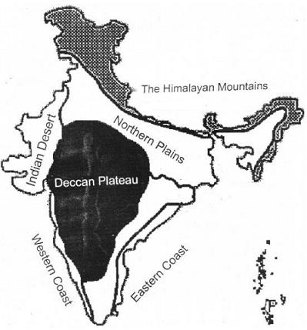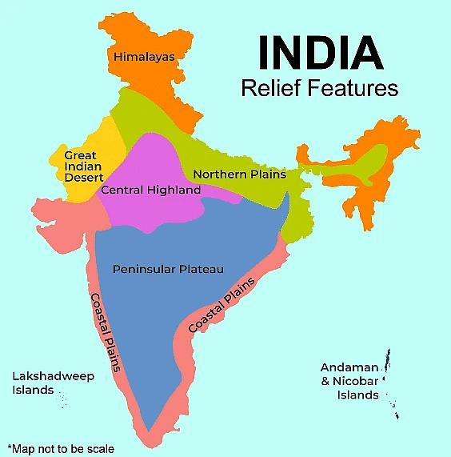

🌄📍 Deccan (डेक्कन) में कौन-कौन से राज्य आते हैं?
Deccan Plateau कोई “एक राज्य” नहीं है, बल्कि यह दक्षिण-मध्य भारत का बड़ा भौगोलिक क्षेत्र (plateau region) है।

🗺️ 🏛️ Deccan में आने वाले मुख्य राज्य:
🟢 1. पूरी तरह/मुख्य रूप से Deccan में
- Maharashtra
- Karnataka
- Telangana
- Andhra Pradesh (Deccan interior part)

🟡 2. आंशिक रूप से (partly Deccan region)
- Madhya Pradesh (दक्षिणी हिस्सा)
- Tamil Nadu (कुछ northern plateau areas)

🌊 ध्यान रखने वाली बात:
👉 Deccan में coastal areas (तटीय मैदान) शामिल नहीं होते
👉 जैसे:
- Mumbai coast
- Chennai coast

🧠 आसान समझ:
- North India = plains
- South India = mix
- Deccan = South India का बीच वाला ऊँचा पठारी भाग

📌 One-line UPSC answer:
👉 Deccan Plateau में मुख्यतः Maharashtra, Karnataka, Telangana और Andhra Pradesh आते हैं, जबकि Madhya Pradesh और Tamil Nadu के कुछ हिस्से भी इसमें शामिल हैं।

अगर चाहो तो मैं तुम्हें map marking trick (Prelims के लिए याद करने का आसान तरीका) भी सिखा दूँ 👍
indian subocntine tme norht and south ka devision kais hai
🗺️📍 Indian Subcontinent में North और South का division कैसे होता है?
👉 भारत (Indian subcontinent) को North और South में भौगोलिक (geographical) आधार पर बाँटा जाता है, न कि सिर्फ राज्य देखकर।

⛰️ 1. सबसे important dividing line
👉 विंध्य पर्वत (Vindhya Range) और नर्मदा नदी (Narmada River)
Vindhya Range
Narmada River

📌 आसान नियम:
👉 Vindhya के ऊपर = North India
👉 Vindhya के नीचे = South India

🧭 2. North India (उत्तरी भाग)
इसमें क्या आता है:
- Ganga-Yamuna plains (मैदान)
- Himalayas region
- Punjab, Haryana, UP, Bihar
- Rajasthan (western part)
👉 जमीन: mostly मैदान (flat land)

🌄 3. South India (दक्षिण भाग)
इसमें क्या आता है:
- Deccan Plateau
- Tamil Nadu, Kerala, Karnataka, Andhra Pradesh, Telangana
Deccan Plateau
👉 जमीन: mostly पठार (plateau) + ghats + coastal areas

🧠 4. Simple Trick (Exam में याद रखने के लिए):
👉 ऊपर = Himalaya + Plains = North
👉 नीचे = Plateau + Peninsula = South

📌 One-line UPSC answer:
👉 Indian subcontinent में North और South का division मुख्यतः Vindhya Range और Narmada River के आधार पर किया जाता है—जहाँ North में plains और South में Deccan Plateau आता है।

अगर चाहो तो मैं तुम्हें इसका बहुत आसान map diagram (exam revision trick) भी बना कर दे सकता हूँ 👍

